DIS-MEX-Mezcala-Head-ex AMNH

A mezcala precolumbian head.

Ex. Jesse R. Sumter, Bloomfield, New Jersey. Collection acquired from 1955 to 1959 by Dr. Bernal Diaz, Director, Museo Nacional, Mexico, D. F., and cleared for export to the U.S. by him. Collection authenticated in 1960 by Dr. Gordon M Eckholm, Curator, The American Museum of Natural History.

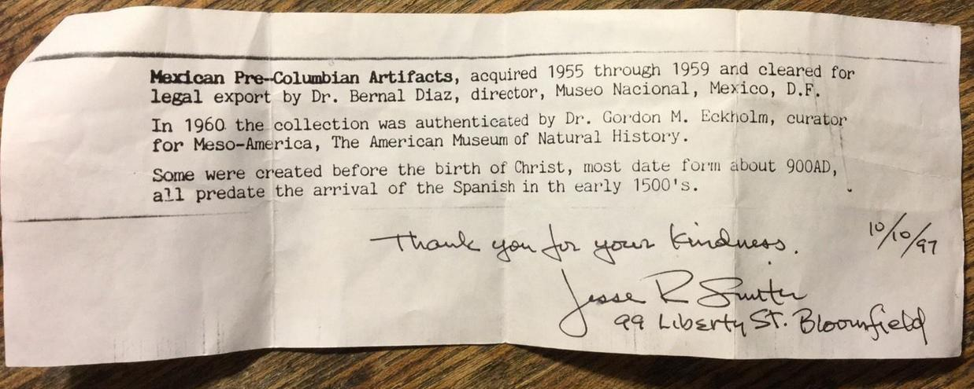\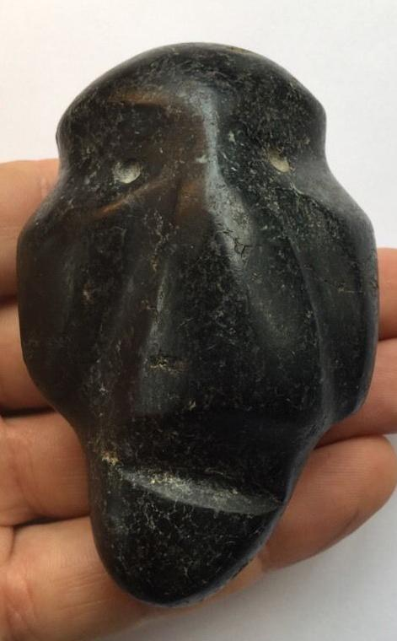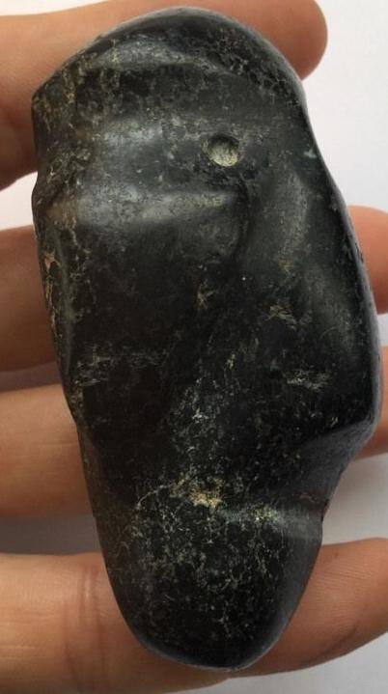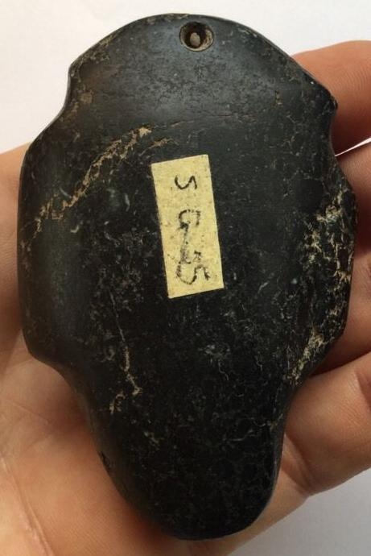

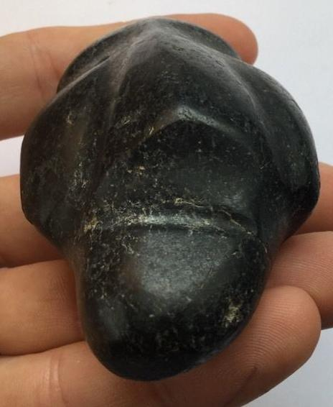

Estimated delivery Saturday, Apr 2, 2016 - Wednesday, Apr 6, 2016

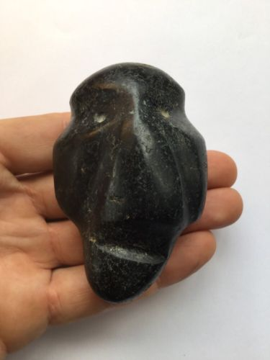

#### [mezcala precolumbian head](http://www.ebay.com/itm/271930909064)

|  |  |
| --- | --- |
| Item price | $259.00 |
| Quantity | 1 |
| Item number | 271930909064 |
| Shipping service | USPS Priority Mail |

## Shipping address

Ralph J Coffman Jr

149 Atlantic Ave

Swampscott MA 01907-2427

United States

## Order total

|  |  |
| --- | --- |
| Subtotal | $259.00 |
| Shipping | $6.70 |

**Total**

$265.70

Order placed on

Friday, Mar 25, 2016

Payment method

PayPal

Payment date

Friday, Mar 25, 2016